Data Sources for American Higher Education

Many of us hold misconceptions about higher education. Therefore, it is important that we closely examine all of our beliefs and verify them against the best data available and even then approach the data with some skepticism.

For example, a common statement is that most college students today are non-traditional, meaning, I would presume, that they are older and have some prior college experience. Below are data from the National Center for Educational Statistics and, as you can see, the vast majority of college students are 25 years old or younger. For 4-yr schools the number is 85% and for 2-yr schools it is 79%.

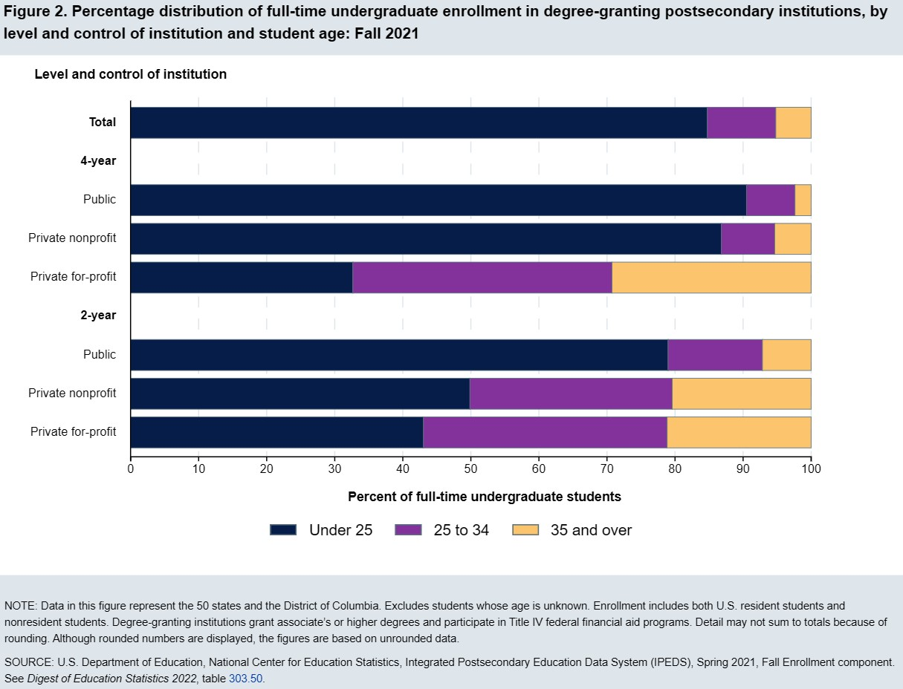

Source: https://nces.ed.gov/programs/coe/indicator/csb/postsecondary-students

Another statement that is common is that our state has one of the best graduation rates in the country. Below is a snapshot for the 2016 cohort entering a Florida institution reported as Student Achievement Measures. As you can see, we have considerable room for improvement in terms of graduation rates.

State | Total rate | Starting institution | Different  4-yr | Different  2-yr | Still  Enrolled | Not  Enrolled
Nat'l | 61.2% | 48.4% | 9.5% | 3.3% | 14.2% | 24.6%
FL | 54.3% | 42.7% | 10.2% | 1.4% | 13.9% | 31.8%
https://nscresearchcenter.org/completing-college/
Let’s begin with the basic resources that anyone interested in higher education data should be familiar with.

National Center for Education Statistics. The National Center for Education Statistics (NCES) is the primary federal entity for collecting and analyzing data related to education.
http://nces.ed.gov/

IPEDS. Integrated Postsecondary Education Data System
Primary source for data on colleges, universities, and technical and vocational postsecondary institutions in the United States from the National Center for Education Statistics.
http://nces.ed.gov/ipeds

Digest of Education Statistics. Compilation of statistical information covering American education from prekindergarten through graduate school.
http://nces.ed.gov/programs/digest

Historically Black Colleges and Universities. Historical data on historically black colleges and universities (HBCUs) from the National Center for Education Statistics can be found at: https://nces.ed.gov/pubsearch/pubsinfo.asp?pubid=2004062

NEA Almanac of Higher Education. Includes information on faculty salaries and benefits, the economic conditions in the states, faculty workload, trends in bargaining, and information on non-faculty professionals on campus.
https://www.nea.org/about-nea/our-members/higher-education-faculty-staff

Campus Security Data Analysis. Data on campus crime from the Office of Postsecondary Education of the U. S. Department of Education.
https://ope.ed.gov/campussafety/#/

Open Doors (Institute of International Education). Information resource on international students and scholars studying or teaching at higher education institutions in the United States, and U.S. students studying abroad for academic credit at their home colleges or universities.
http://www.iie.org/en/Research-and-Publications/Open-Doors

State Postsecondary Education Structures Handbook. Statistical and narrative profiles of each state's higher education structure compiled by the Education Commission of the States.
https://diginole.lib.fsu.edu/islandora/object/fsu:267109

National Longitudinal Survey of Freshmen. NLSF was designed to provide comprehensive data to test different theoretical explanations for minority underperformance in college.
https://web.sas.upenn.edu/nlsf19992003/about/

Grapevine. Annual compilation of data on state fiscal support for higher education.
http://grapevine.illinoisstate.edu/

Delta Cost Project (American Institutes for Research). Analyzes data on spending in higher education and continues to be updated periodically.
https://www.air.org/project/delta-cost-project

Council of Graduate Schools. Includes information, data analysis, trends, and best practices in graduate education.
http://www.cgsnet.org/

Condition of Education. Annual report on indicators of important developments and trends in U.S. education compiled by the National Center for Education Statistics.
https://nces.ed.gov/programs/coe/

Data.gov. Data from U.S. government statistical reports.
www.data.gov/

Statistical Resources on the Web: Education. Meta-site providing links to many sources of education data on the Web.
https://guides.lib.umich.edu/govinfo

U.S. Census Bureau - Education. Census data on educational attainment, field of study, school enrollment, and school costs.
https://www.census.gov/topics/education/educational-attainment.html

Science and Engineering Indicators 2020. Updated Annually
https://ncses.nsf.gov/indicators

NSF Academic Institution Profiles
http://ncsesdata.nsf.gov/profiles/

NCSES Interactive Tool. An interactive tool consolidates several previous platforms into one system. You can easily create custom tables to suit your specific research needs. Currently, the tool can be used to access data from the Survey of Earned Doctorates (SED) and Survey of Graduate Students and Postdoctorates in Science and Engieering (GSS). As new NCSES data are released, they will be added to the tool. In addition, the tool provides access to data from surveys from the WebCASPAR platform, which will be inaccessible towards the end of 2018. Soon, the NCSES tool will be updated with data from surveys from SESTAT and other NCSES platforms.
https://ncsesdata.nsf.gov/ids

Web of Knowledge. Available in most libraries as The Web of Science. https://clarivate.com/products/web-of-science/

Student indebtedness. Provides ineractive map and report on student debt for specific years along with resources for borrowers.
https://ticas.org/posd/home

Delaware Cost Study of Faculty Workload. Provides a report of annual study of instructional costs and productivity that has been widely used since 1992. Some summary information is freelyh available with full results contingent on the participation in the annual survey and receipt of a fee.
http://ire.udel.edu/cost/

The Center for Measuring University Performance. Focuses on the competitive national context for major research universities and publishes a report on the Top American Research Universities which is updated annually.
https://mup.umass.edu/

NSSE- The National Center of Student Engagement. Reports annual on results of a student survey concerning student engagement along with results of a faculty survey as well.
http://nsse.indiana.edu/

COACHE- The Collaborative on Academic Careers in Higher Education. The Collaborative on Academic Careers in Higher Education (COACHE) is a Harvard-based consortium of institutional leaders who are taking cost-effective steps to improve outcomes in faculty recruitment, development, and retention.
http://coache.gse.harvard.edu/

Data on salaries. Produces a report concerning a survey of graduates of more than 2,700 colleges and universities regarding graduates’ pay, majors, and highest degree earned.
http://www.payscale.com/

The National Center for Educational Statistics regularly issues reports of considerable value to policy makers and academic administrators. For example, one focuses on STEM students: STEM Attrition: College Students’ Paths Into and Out of STEM Fields. http://nces.ed.gov/pubs2014/2014001rev.pdf

NCES not only has a huge amount of data on education in the United States but the site offers statistical tools to assist users in analyzing data. A powerful tool (and easy to use) is POWERSTATS that includes tutorial to assist the user.

The National Student Clearinghouse operates the National Student Clearinghouse Research Center that analyzes data and issues very interesting reports. The reports follow students through their postsecondary careers across institutions for those students who change institutions.
http://nscresearchcenter.org/

Another interesting site is College Measures.Org. College Measures is a joint venture of American Institutes for Research and Matrix Knowledge Group but I have no other information on the group or how the data is collected.
https://www.air.org/center/college-measures/

A very interesting blog to follow is Higher Ed Data Stories. The author is Jon Boeckenstedt, VP for Enrollment Management at a major university but the material is developed on his own.
http://highereddatastories.blogspot.com/

State University System. Almost every state higher education organization has a website with data. This is the one for the State University System of Florida.
https://www.flbog.edu/universities/key-university-info/university-fact-books/

More specific sites are listed below for Florida Information.

Southern Regional Education Board is also a good data source for southern schools.
http://www.sreb.org/

The Common Data Set : The Common Data Set (CDS) initiative is a collaborative effort among data providers in the higher education community and publishers as represented by the College Board, Peterson's, and U.S. News & World Report. The combined goal of this collaboration is to improve the quality and accuracy of information provided to all involved in a student's transition into higher education, as well as to reduce the reporting burden on data providers.

The Common Data Set is institution specific and is usually found associated with Institutional Research on the institution’s web page e.g.,
http://www.ir.fsu.edu/commondataset.aspx

These data allow different kinds of comparisons as, for example, the percentage of funds spent on need-based versus non-need based aid at various public universities.(see (http://hechingerreport.org/troubling-use-merit-aid-public-flagships-research-universities/)
http://www.commondataset.org/

Websites that organize information.

The National Center for Higher Education Management Systems (NCHEMS) is a very good site.
http://www.higheredinfo.org/resources.php

The State Higher Education Executive Officers also offers information.
http://www.sheeo.org/policy-issues/data-and-information

The Higher Education Research Institute (HERI) at UCLA is home to the Cooperative Institutional Research Program. This is the annual survey of First Time college students that covers a wide range of questions and is always an interesting read.
http://www.heri.ucla.edu/

The Center on Education and the Workforce at Georgetown University is another valuable site with important research publications that are available online. As the title indicates, the emphasis here is on employment and education.
http://cew.georgetown.edu

The President’s College Scorecard. This is part of a federal effort to give colleges and universities a score that may affect their federal financial aid funding (Title IV). This scorecard includes data on more than 7,000 institutions derived by IPEDS, the National Student Loan Data Systems and tax records.
https://collegescorecard.ed.gov/

The President’s College Scoreboard site is linked to another on college costs and transparency and includes a “Cost Calculator” to help families estimate the actual cost of attending college.
http://collegecost.ed.gov/

Higher Education Periodicals

Inside Higher Education
http://www.insidehighered.com/#sthash.YxQwPnC4.dpbs

The Chronicle of Higher Education, especially their Facts and Figures section.
http://chronicle.com/section/Home/5

The Chronicle’s Facts and Figures, data on college completion.
http://collegecompletion.chronicle.com/

Help for students as they decide on a major in college
There are a number of free web resources that may help students select a major.

http://www.mynextmove.org/
http://www.onetonline.org/
http://www.bls.gov/ooh/
http://www.glassdoor.com/index.htm

This site is free but requires registration and attempts to guide students toward a major and then identify those schools that offer the major and seems a good fit based on the student’s responses to the survey questions.
http://www.mymajors.com/

Graduation and retention detailed data on individual institutions
A few comments are in order on undergraduate retention and graduation rates as it is important to understand a few distinctions among the various data sites.

The central official source for educational data is the National Center for Educational Statistics.
https://nces.ed.gov/

It is the most important of all educational data sites. Within this site, primary data for postsecondary institutions are found in the Integrated Postsecondary Education Data System (IPEDS). http://nces.ed.gov/ipeds/
These are the data commonly reported when retention and graduation rates are discussed. The most important distinction here is that the rates reported are based on the entering cohort of First Time Full Time students defined as those students entering in the summer who continue into the fall as well as those students who start in the fall. And of course, First Time means that this is the first postsecondary experience for these students. These data come from the Common Data Set that is a required federal report submitted by institutions.

Another measure of retention and graduation is the Student Achievement Measure (SAM).
http://www.studentachievementmeasure.org/

This measure uses data from the National Student Clearinghouse and follows all students who enter postsecondary institutions even if they transfer schools.
http://www.studentclearinghouse.org/
For example, if a student enters school A and two years later transfers to school B the National Student Clearinghouse will track the student through both institutions.

The SAM data are usually reported in the format below for an institution.
http://www.studentachievementmeasure.org/participants

In the FSU example on the following page the IPEDS 6-Year graduation rate would be 86% for the First Time at Institution, Full-Time Students Starting Fall 2016 with another 8% graduating from another institution; 1% are still enrolled at the reporting institution and 2% at another institution.

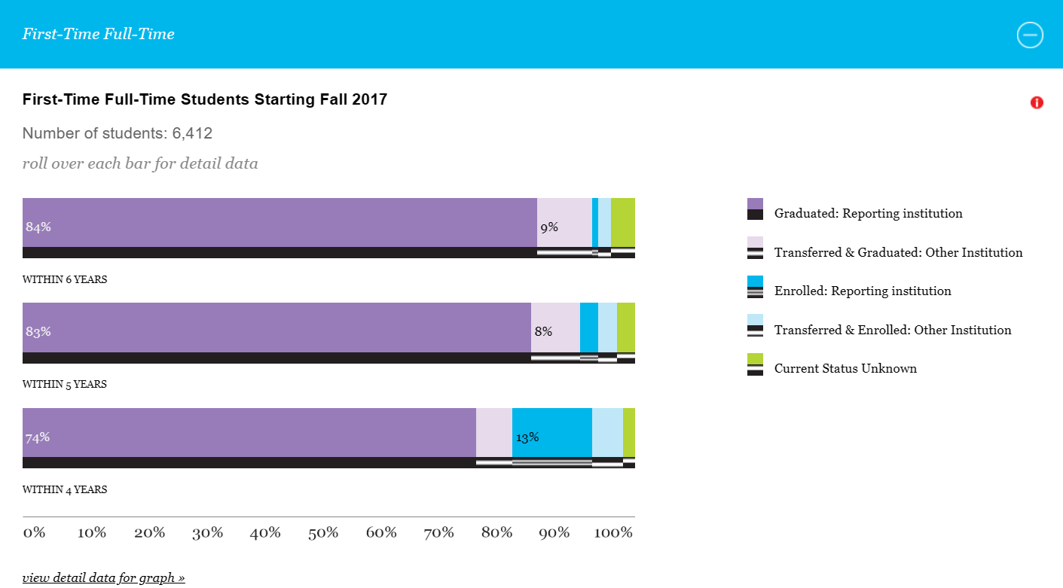

There are a very large number of websites that report data on post-secondary education and it is important to read them carefully before using the data.

Undergraduate Data
The best site for undergraduate data from both four-year and two-year schools is the College Navigator.
http://nces.ed.gov/collegenavigator

It is worth reading all of the reported material for a school as it contains a large amount of important information in the categories shown below.

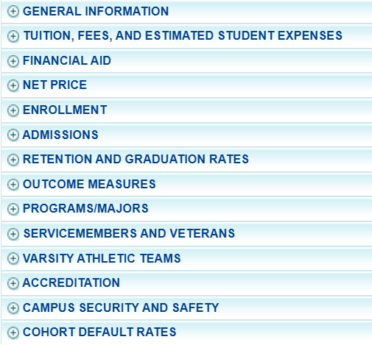

The Education Trust. Another valuable site for four-year schools is one maintained by The Education Trust, an organization that provides information on higher education with a focus on underrepresented students.
http://www.edtrust.org/

College Results Online. This site uses IPEDS data and includes several valuable options, including comparisons of retention and graduation rates for underrepresented students as well as five-year trend lines for graduation rates. One of the most valuable options is “Similar Colleges.” The site clusters 15 or more institutions comparable to the one selected based on numerous variables, such as student demographics, student academics including high school GPA, expenditures and geographic setting. This allows comparisons of retention, graduation rates as well as other variables among these institutions.
http://www.collegeresults.org/

An example is shown below:

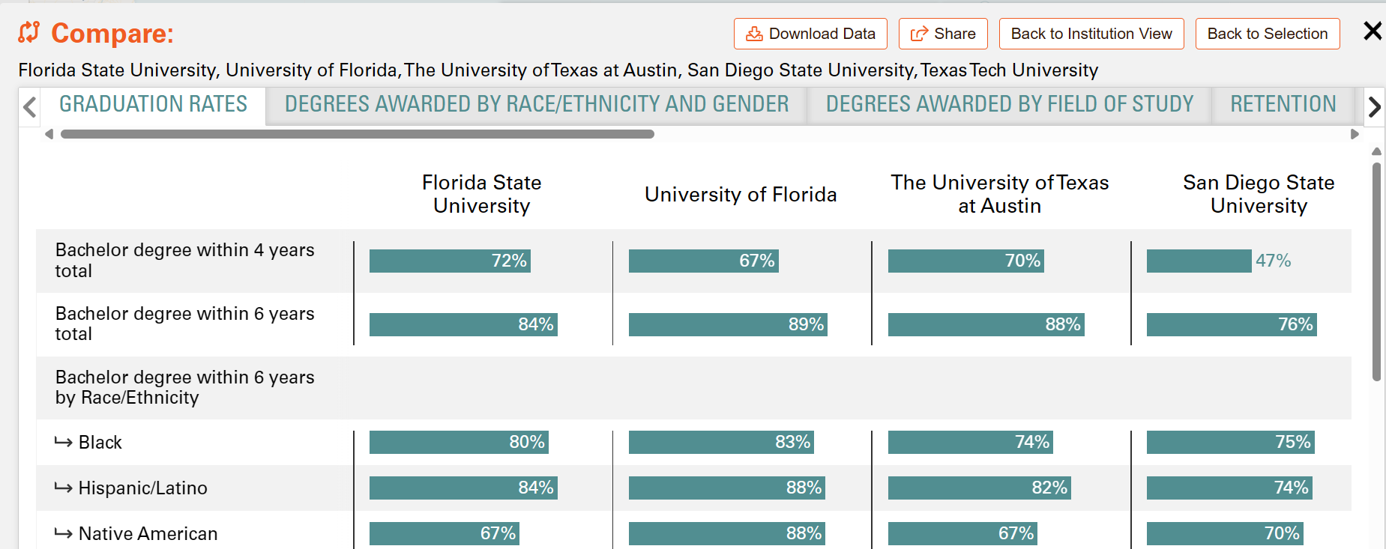

Research
Most, but not all, public 4-year institutions are apparently dissatisfied with their current status with respect to research and there is near constant discussion on these campuses on efforts to achieve “Research I” status, a classification that is no longer used and has been replaced by RU/VH, meaning “Research universities (very high research activity)” by the Carnegie Foundation, the group that classifies universities largely by their mission.
https://www.carnegiefoundation.org/our-work/postsecondary-innovation/carnegie-classifications/

For example, there are a number of universities that have “research” as their top priority and student success somewhere down the list. Many of these institutions graduate less than 30% of their students and an examination of their federal research funding and faculty activity strongly suggest that it is not a good use of resources to focus on achieving “Research I” status. Their region, state and country would be much better served by focusing on student success.

Since a university’s classification is based in part on research funding, it is worth pointing out that caution is necessary when interpreting how institutions report their research funding. The critical data are “Federal obligations in science, engineering an health” and are reported in several data reports, such as NSF Institutional Profiles.
http://ncsesdata.nsf.gov/profiles/

These numbers come from the federal agencies listed and are audited and are the ones you should pay attention to if you are interested in an institution’s research funding.

Research funding is reported as “R&D expenditures” and includes what was actually spent that year and may not match federal obligations for several reasons. First, any non-S&E (Science & Engineering) funding the institution may have is included and second, many grants are multiyear while agencies obligate the total funding the first year of the award. Finally, you should pay close attention to the actual report and see what the institution reports under “Institutional funds.” For example, one university may report $500 million in R&D expenditures while another may report only $400 million but the first institution reports spending $200 million in institutional funds (its own money, not grants competitively awarded) while the second only reports $50 million. Most observers would conclude that the second institution has a larger research portfolio.

Information Concerning Universities in Florida

www.leg.state.fl.us/ The official site of the Florida Legislature with links to information about legislation and data used in the legislative process

https://www.dms.myflorida.com/agency_administration/planning_budget_and_fiscal_integrity/florida_fiscal_portal2 This houses a collection of documents that detail the fiscal status of the State of Florida including information on the agencies and significant annual publications

http://www.oppaga.state.fl.us/
The Florida Legislature’s Office of Program Policy Analyis and Government Accountability with reports, program summaries and policy presentations listed by topic area.

https://flauditor.gov/
Provides financial and operational audits of universities and Board of Governors.

http://www.stateofflorida.com/
General site for finding information concerning Florida government information

The Florida Statutes. A valuable site references Florida law. The sections containing education code are included in Chapters 1000-1013. http://www.leg.state.fl.us/Statutes/index.cfm?Mode=View%20Statutes&Submenu=1&Tab=statutes&CFID=86365824&CFTOKEN=839e786ee3ddae4e-CB43266B-EA05-F085-63F729B02744CC29

One particular site often requested by chairs during this workshop is related to the “12 Hour Law”. Section 1012.945 Required number of classroom teaching hours for university faculty members. http://www.leg.state.fl.us/Statutes/index.cfm?App_mode=Display_Statute&Search_String=&URL=1000-1099/1012/Sections/1012.945.html

Reference Books for Department Chairs

The Essential Department Chair: A Comprehensive Desk Reference, 2nd Edition by Jeffrey L. Buller. January 2012. Hardcover. Jossey-Bass.

The Department Chair Primer: What Chairs Need to Know and Do to Make A Difference, 2nd Edition by Don Chu. February 2012. Paperback. Jossey-Bass.

Positive Academic Leadership: How to Stop Putting Out Fires and Start Making a Difference by Jeffrey L. Buller.

The Department Chair. A Journal. Jossey-Bass.

Academic Leadership: A Practical Guide to Chairing the Department, 2nd Edition by Deryl R. Leaming.

Managing People: A Guide for Department Chairs and Deans by Deryl R. Leaming.

Leading Academic Change: Essential Roles for Department Chairs by Ann F. Lucas. March 2000. Hardcover. Jossey-Bass.

Communication Skills for Department Chairs by Mary Lou Higgerson, William E. Cashin, Walter H. Gmelch. August 1996. Hardcover. Jossey-Bass.

Best Practices in Faculty Evaluation: A Practical Guide for Academic Leaders by Jeffrey L. Buller.

The Teaching Portfolio: A Practical Guide to Improved Performance and Promotion/Tenure Decisions, 4th Edition, by Peter Seldin, J. Elizabeth Miller, Clement A. Seldin, Wilbert McKeachie. August 2010. Paperback. Jossey-Bass.

The Academic Portfolio: A Practical Guide to Documenting Teaching, Research, and Service by Peter Seldin, J. Elizabeth Miller. October 2008. Paperback. Jossey-Bass.

The Administrative Portfolio: A Practical Guide to Improved Administrative Performance and Personnel Decisions by Peter Seldin, Mary Lou Higgerson. December 2001. Hardcover. Jossey-Bass.

Strengthening Departmental Leadership: A Team Building Guide for Chairs in Colleges and Universities by Ann Lucas. October 1994. Jossey-Bass.

Time Management for Department Chairs by Christian K. Hansen. July 2011. Paperback. Jossey-Bass.

Working with Problem Faculty: A Six-Step Guide for Department Chairs by R. Kent Crookston. September 2012. Hardcover. Jossey-Bass.

The University: An Owner’s Manual by Henry Rosovsky. 1990. W. W. Norton & Company.

Leading Change by John P. Kotter. September 1996. Hardcover. Harvard Business Review Press.

Books on Leadership

7 Habits of Highly Effective People by Stephen R. Covey. Simon & Schuster.
- Be proactive
- Begin with the end in mind
- Put first things first (important and urgent)
- Think win-win
- Seek first to understand, then to be understood
- Synergize – combine strengths through positive teamwork
- Sharpend the saw – balance and renew yourself

One Minute Manager by Kenneth Blanchard and Spencer Johnson. Berkley Books.
- One minute goals
- One minute praising
- One minute reprimands

When Employees Don’t Do What They’re Supposed to Do by Fournies. McGraw-Hill.

- Top Reasons Why Employees Don’t Do What They Are Supposed to Do:
They don’t know why they should do it
They don’t know how to do it
They don’t know what they are supposed to do
They think your way will not work
They think their way is better
They think something else is more important
There is no positive consequence to them for doing it
They think they are doing it
They are punished for doing what they are supposed to do
They anticipate negative consequence for doing it
There is no negative consequence to them for poor performance
There are obstaclces beyond their control
Their persoml limits prevent them from performing
Person problems
No one could do it

Such roadblocks can be minimized by:
Getting agreement that a problem exists
Mutually discussing alternative solutions
Mutually agreeing on action to be taken to solve the problem
Following-up to ensure that agreed-upon action has been taken
Reinforcing any achievement

Our Iceberg is Melting by John Kotter and Holger Rathgeber. St. Martin’s Press.
- Steps for Successful Change
  - Create a sense of urgency
  - Pull together a guiding team
  - Develop the Change vision and strategy
  - Communicate for understanding and buy in
  - Empower other to act
  - Produce short-term wins
  - Don’t let up
  - Create a new culture

Gung Ho by Ken Blanchard and Sheldon Bowles. William Morrow and Company.
Make sure employees know why their work is important
Give them control of how they do their jobs
Provid encouragement

How the Way We Talk Can Change the Way We Work: Seven Languages for Transformation by Robert Kegan, and Lisa Laskow Lahey. Jossey-Bass.
Seven Languages for Transformation
  - Moving from the language of complaint to the language of commitment
  - Moving from the language of blame to the language of personal responsibility
  - Moving from the language of resolutions to the language of competing commitments
  - Moving form the language to assumptions that constrain us to the language of assumption that we hold
  - Moving form the languate of prizes and praising to the language of ongoing regard
  - Moving form the languae of rules and policies to the language of public agreement
  - Moving from the languae of constructive criticism to the language of fundamental distinctions

Death by Meeting by Patrick Lencioni. Jossey-Bass.
- Meetings are not inherently bad
- They can be bad when they lack drama and are engaging – demanding that people wrestly with the controversial issues
- They can be bad if they lack context and people don’t know why they are taking place
- Types of meetings:
  - Daily check-in
  - Weekly Tactical
  - Monthly Strategic
  - Quarterly Off-site review

Silos, Politics and Turf Wars by Patrick Lencioni. Jossey-Bass.

The Five Dysfunctions of a Team by Patrick Lencioni. Jossey-Bass.
- Absence of trust
- Fear of conflict
- Lack of commitment
- Avoidance of accountability
- Inattention to results

The Five Temptations of a CEO by Patrick Lencioni. Jossey-Bass.
- Choosing status over results
- Choosing popularity over accountability
- Choosing certainty over clarity
- Choosing harmony over productive conflict
- Choosing invulnerability over trust

Leading Change by John P. Kotter. Harvard Business School Press.
- Most transformational efforts fail
- They founder during at least one of the following phases:
  - Generating a sense of urgency
  - Establishing a powerful fuiding coalition
  - Developing a vision
  - Communicating the vision clearly and often
  - Removing obstacles
  - Planning for and creating short term wins
  - Avoiding premature declearation of victory
  - Embedding changes in the corporate culture

